SQL
Create Table
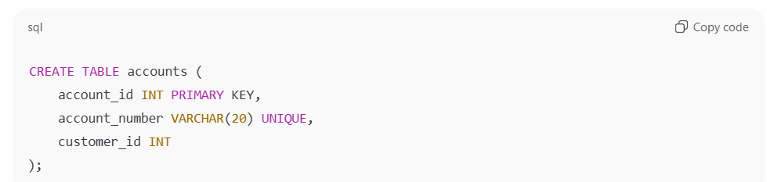
Foreign Key
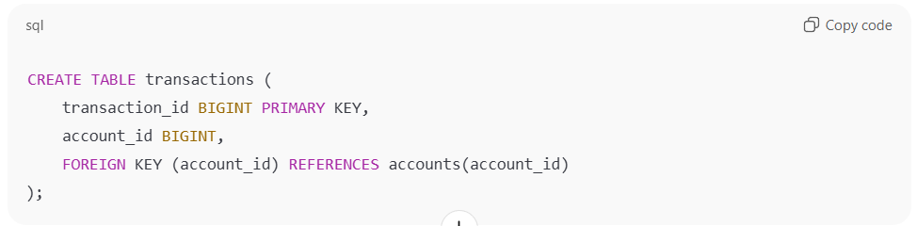
AUTO_INCREMENT
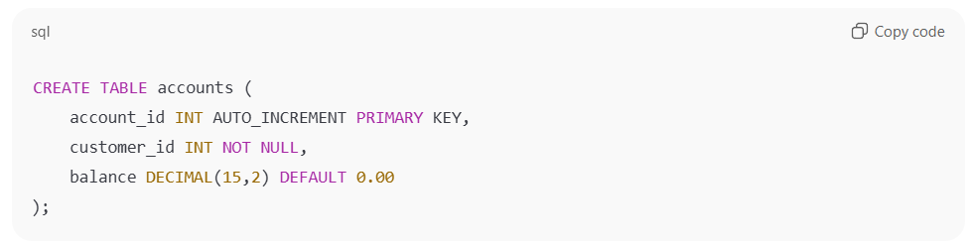
Distinct Keyword
SELECT DISTINCT Country FROM Customers;

Insert

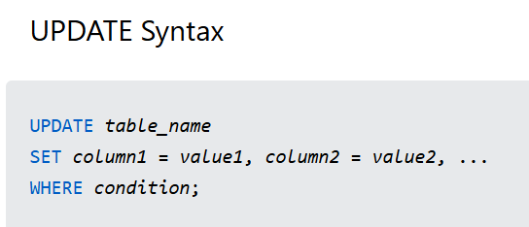

Basic Queries:
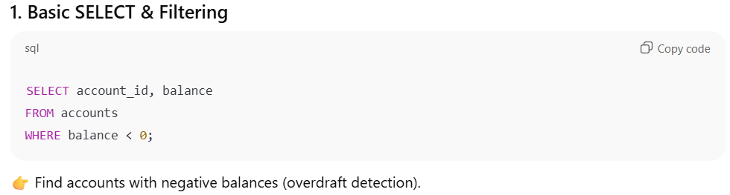
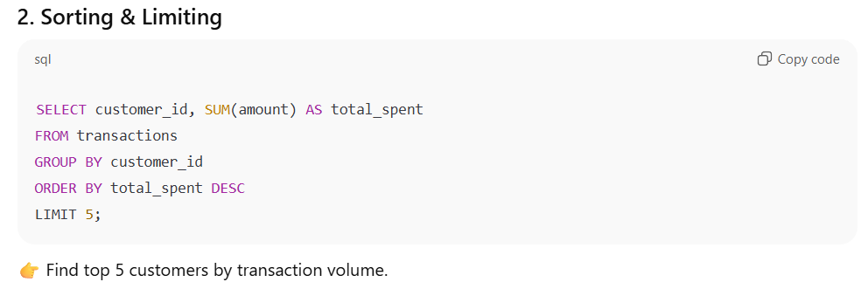
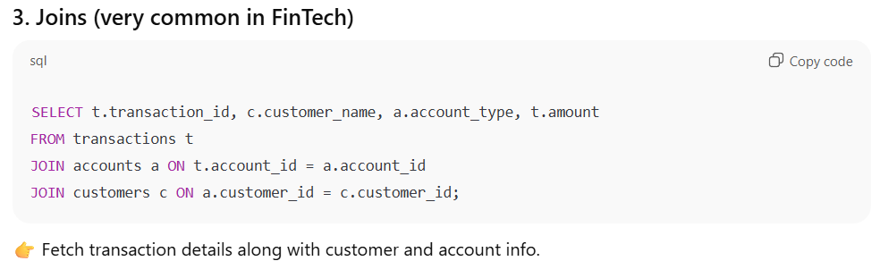
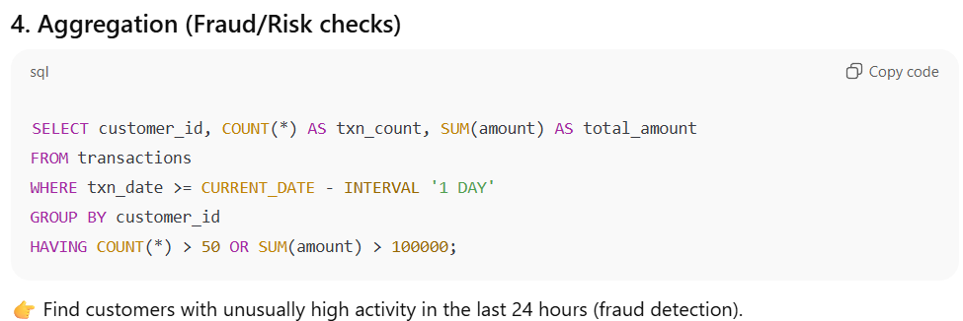
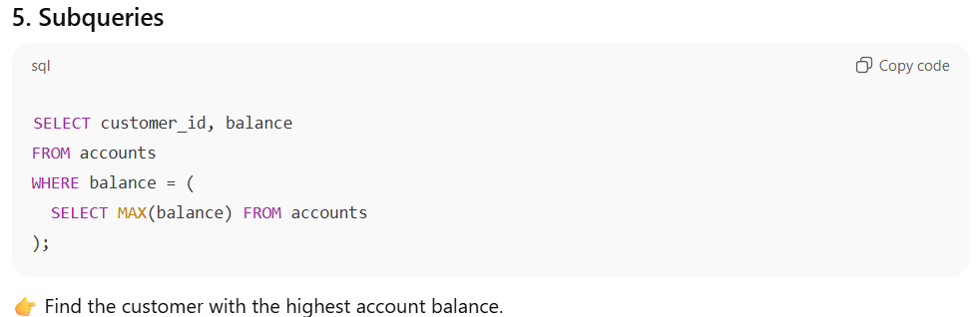
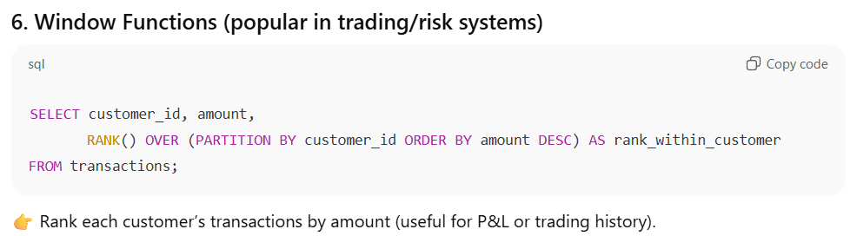
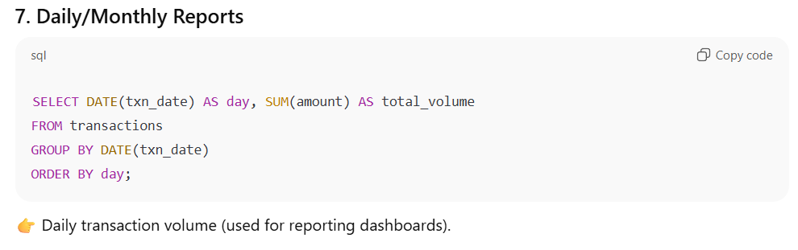
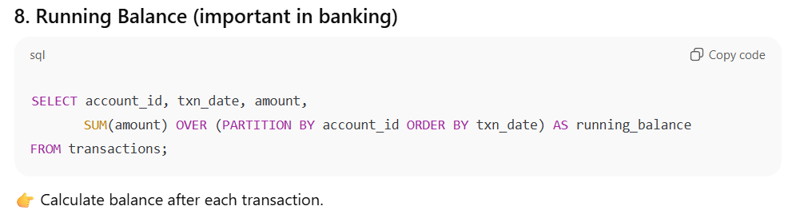
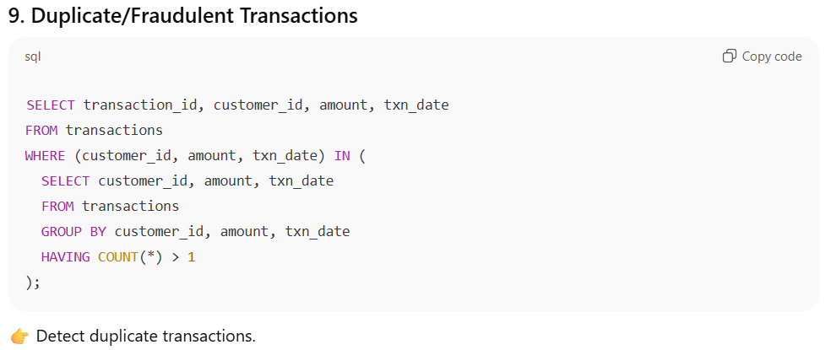
TOP Keyword
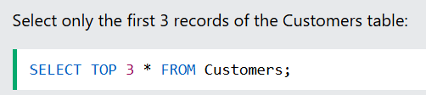

The SQL UNION Operator
The UNION operator is used to combine the result-set of two or more SELECT statements.
The UNION operator automatically removes duplicate rows from the result set.
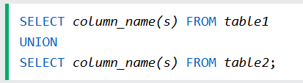
Joins
INNER JOIN
The INNER JOIN keyword selects records that have matching values in both tables.
SQL LEFT JOIN Keyword
The LEFT JOIN keyword returns all records from the left table (table1), and the matching records from the right table (table2). The result is 0 records from the right side, if there is no match.
CASE
